

**CAPSTONE PROJECT**

**Software Requirement Specification**

- Hanoi, Jan 4, 2024 –

I. Project Report 2

1. Status Report 2

2. Team Involvements 3

3. Issues/Suggestions 3

II. Software Requirement Specification 3

1. Overall Description 3

1.1 Product Overview 3

1.2 Business Rules 4

2. User Requirements 4

2.1 Overview 5

a. Use Case Diagram 5

Admin 5

Staff 6

User 7

Guest 8

b. System Actors 8

c. Use Cases List 9

2.2 Use Case Specification 10

2.2.1. Guest 10

2.2.1.1 Sign up 10

2.2.1.2. View home 11

2.2.1.3. View product detail 11

2.2.1.4. Search product 12

2.2.1.5 Add to cart 12

2.2.1.6 View cart 13

2.2.1.7 Payment 13

2.2.2. Admin 14

2.2.2.1. Log in 14

2.2.2.2 Log out 14

2.2.2.3 View accounts list 15

2.2.2.4 Create account 15

2.2.2.5 Delete account 16

2.2.2.6 Disable account 17

2.2.2.7 Enable account 17

2.2.2.8 Update account 18

2.2.2.9 View products list 18

2.2.2.10 Create product 19

2.2.2.11 Update product 19

2.2.2.12 Delete product 20

2.2.2.13 View orders list 21

2.2.2.14 View order detail 21

2.2.2.15 View coupons list 22

2.2.2.16 Create coupon 23

2.2.2.17 Update coupon 23

2.2.2.18 Delete coupon 24

2.2.2.19 Search product 25

2.2.2.20 Search account 25

2.2.2.21 View categories list 26

2.2.2.22 Create category 26

2.2.2.23 Update category 27

2.2.2.24 Delete category 28

2.2.3. Staff 28

2.2.3.1. Login 28

2.2.3.2 Log out 29

2.2.3.3 View accounts list 29

2.2.3.4 Update account 30

2.2.3.5 View coupons list 31

2.2.3.6 Change delivery status 31

2.2.3.7 Confirm payment 32

2.2.3.8 View orders list 32

2.2.3.9 View order detail 33

2.2.3.10 View products list 34

2.2.3.11 Search product 34

2.2.3.12 Create product 35

2.2.3.13.1 Update product 35

2.2.3.13.2 Delete Product 36

2.2.3.14 View home 37

2.2.2.15 View categories list 37

2.2.2.16 Create category 38

2.2.2.17 Update category 38

2.2.2.18 Delete category 39

2.2.4 User 39

2.2.4.1 Login 40

2.2.4.2 Log out 40

2.2.4.3 View home 41

2.2.4.4 View product detail 41

2.2.4.6 Add to cart 42

2.2.4.7 View cart 42

2.2.4.8 Payment 43

2.2.4.9 View order detail 43

2.2.4.10 Update profile 44

2.2.4.11 Forgot password 44

2.2.4.12 Change password 45

2.2.4.13 Search product 46

3. Functional Requirements 46

3.1 System Functional Overview 47

a.Screen Flow 47

b. Entity Relationship Diagram 47

c. Entity List 47

**Project Background**

**Reasons to develop this project**

With the widespread popularity of online social networks, the need to buy and sell directly online is also increasing. Developing an online store is a way for startups to have the potential to grow economically and also avoid unnecessary risks.

**What is an Online Shop?**

Online shopping is a form of electronic commerce which allows consumers to directly buy goods or services from a seller over the Internet using a web browser or a mobile app. Consumers find a product of interest by visiting the website of the retailer directly or by searching among alternative vendors using a shopping search engine, which displays the same product's availability and pricing at different e-retailers.

**I. Project Report**

## **1. Status Report**

|  |  |  |  |
| --- | --- | --- | --- |
| **#** | **Work Item** | **Status** | **Notes (Work Item in Details)** |
| **1** | **Overall Description** | **Completed** |  |
| **2** | **User Requirements** | **Completed** |  |
| **3** | **Functional Requirements** | **Completed** |  |
| **4** | **Other Requirements** | **Completed** |  |

## **2. Team Involvements**

|  |  |  |  |
| --- | --- | --- | --- |
| **#** | **Task** | **Member** | **Notes** |
| **1** | **Overall Description** | **LinhTT** |  |
| **2** | **User Requirements** | **BinhNH** |  |
| **3** | **Functional Requirements** | **AnhNTM** **BinhNH**  **LinhTT** |  |
| **4** | **Other Requirements** | **AnhNTM** |  |

## **3. Issues/Suggestions**

|  |  |  |  |
| --- | --- | --- | --- |
| **#** | **Issue** | **Status** | **Notes (Solution, Suggestion, etc.)** |
| **1** |  | **Pending** |  |
| **2** |  | **In Progress** |  |
| **3** |  | **Completed** |  |

# **II. Software Requirement Specification**

## **1. Overall Description**

### **1.1 Product Overview**

This chapter outlines the functional and non-functional requirements of our system. It

also provides some format constraints in common requirements and project success criteria.

The content of this chapter is used as the basis for the work in the subsequent chapters.

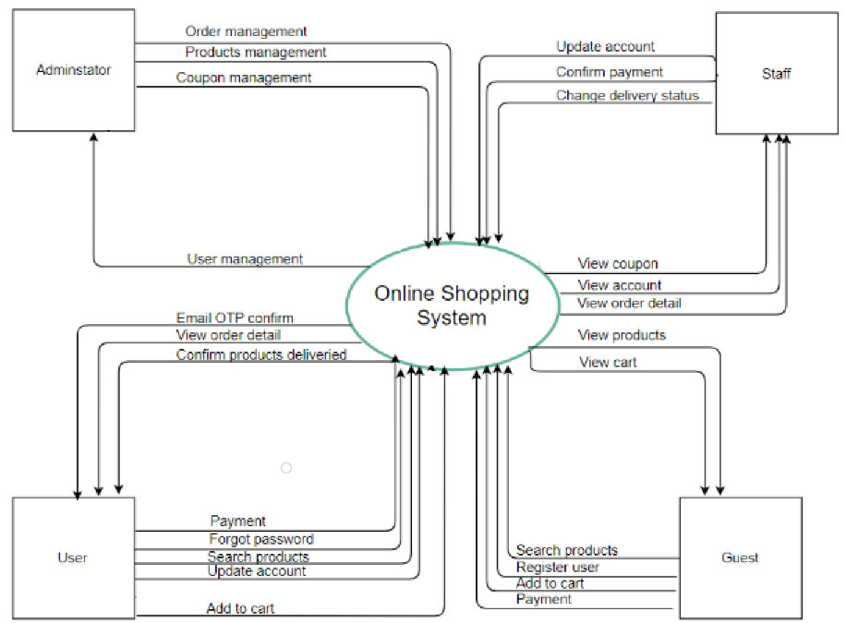

### **1.2 Business Rules**

|  |  |
| --- | --- |
| ID | Description |
| B01 | The phone number must be valid with 10 numeric characters in length. |
| B02 | Password must be encrypted with MD5 Encryption. |
| B03 | When registering or changing a password, a user must enter the new  password twice |
| B04 | A guest cannot register with a email address that has already been registered. |
| B05 | User must provide their email and password when logging into the system. |
| B06 | When changing a password, a new password must not be the same as the  current password. |
| B07 | When an account is registered, the initial role of the account is User. |
| B08 | OTP code must be 8 charactor with no special charactors |

## **2. User Requirements**

### **2.1 Overview**

#### a. Use Case Diagram

#### **Admin**

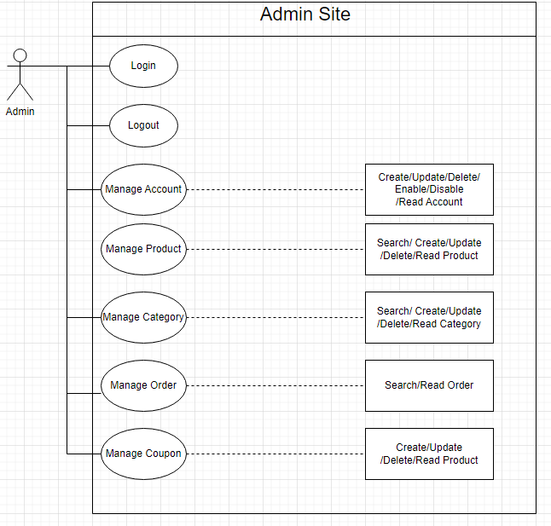

#### **Staff**

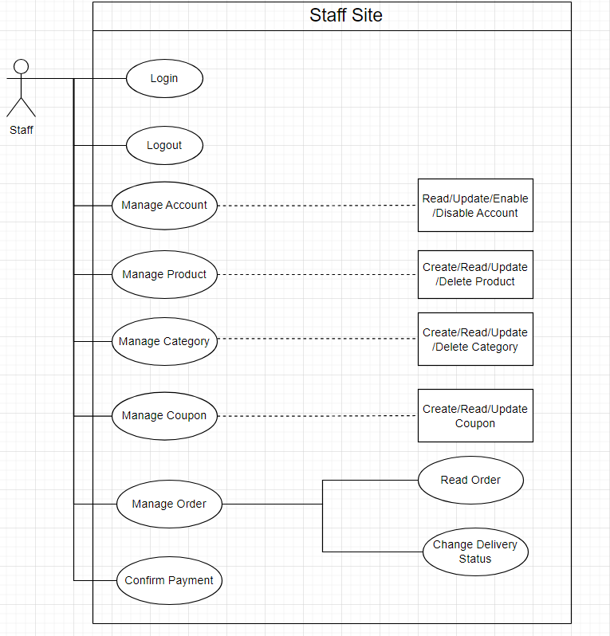

#### 

#### **User**

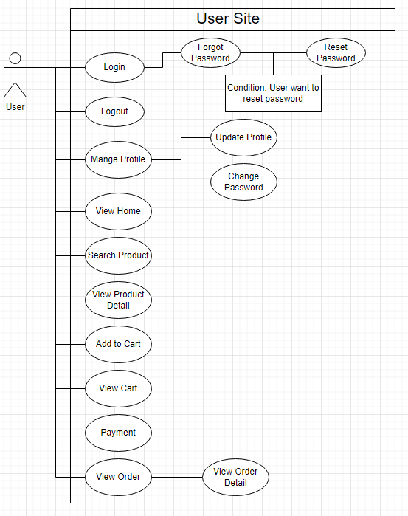

#### **Guest**

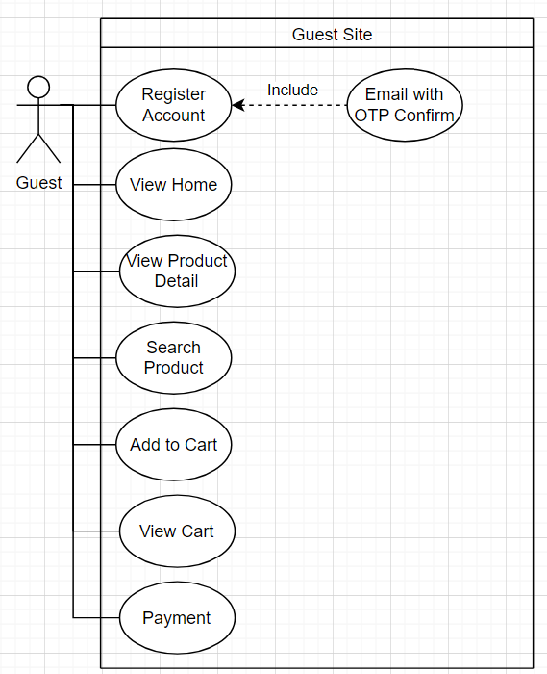

### **b. System Actors**

|  |  |  |
| --- | --- | --- |
| # | Actors | Description |
| 1 | Admin | People who manage the Online Shop System |
| 2 | Staff | People who support admin to manage the Online Shop System |
| 3 | User | The registered user |
| 4 | Guest | The guest that has not yet registered an account |

### **c. Use Cases List**

|  |  |  |  |
| --- | --- | --- | --- |
| ID | Use Case | Primary Actor | Secondary Actor |
| 1 | Sign up | Guest | N/A |
| 2 | View home | Guest/User/Staff | N/A |
| 3 | View product detail | Guest | N/A |
| 4 | Login | User/Staff/Admin | N/A |
| 5 | Logout | User/Staff/Admin | N/A |
| 6 | View accounts list | Admin | N/A |
| 7 | Create account | Admin | N/A |
| 8 | Delete account | Admin | N/A |
| 9 | Disable account | Admin | N/A |
| 10 | Enable account | Admin | N/A |
| 11 | Update account | Admin | N/A |
| 12 | View products list | Staff/Admin | N/A |
| 13 | Create product | Admin | N/A |
| 14 | Update product | Admin | N/A |
| 15 | Delete product | Admin | N/A |
| 16 | View orders list | Admin | N/A |
| 17 | Create order | Admin | N/A |
| 18 | Update order | Admin | N/A |
| 19 | Delete order | Admin | N/A |
| 20 | View order detail | Admin | N/A |
| 21 | View coupons list | Admin | N/A |
| 22 | Create coupon | Admin | N/A |
| 23 | Update coupon | Admin | N/A |
| 24 | Delete coupon | Admin | N/A |
| 25 | View accounts list | Staff | N/A |
| 26 | Update account | Staff | N/A |
| 27 | View coupons list | Staff | N/A |
| 28 | Change delivery status | Staff | N/A |
| 29 | Confirm payment | Staff | N/A |
| 30 | View orders list | Staff | N/A |
| 31 | View order detail | Staff | N/A |
| 32 | View home | User | N/A |
| 33 | View product detail | User | N/A |
| 34 | Add to cart | Guest/User | N/A |
| 35 | View cart | Guest/User | N/A |
| 36 | Payment | Guest/User | N/A |
| 37 | View order detail | Guest/User | N/A |
| 38 | Update profile | User | N/A |
| 39 | Forgot password | User | N/A |
| 40 | Change password | User | N/A |
| 41 | Search product | Guest/User/Staff/Admin | N/A |
| 42 | Create product | Staff | N/A |
| 43 | Update product | Staff | N/A |
| 44 | View categories list | Staff/Admin | N/A |
| 45 | Create category | Staff/Admin | N/A |
| 46 | Update category | Staff/Admin | N/A |
| 47 | Delete category | Staff/Admin | N/A |
| 48 | Delete Product | Staff | N/A |

## **2.2 Use Case Specification**

### **2.2.1. Guest**

#### **2.2.1.1 Sign up**

|  |  |  |  |
| --- | --- | --- | --- |
| **Use Case ID** | UC - 01 | **Use Case Name** | Sign up |
| **Created By** | LinhTT | **Create Date** | 23/1/2024 |
| **Primary Actor** | Guest | **Secondary Actor** | N/A |
| **Description** | Sign up for an account on the system. | | |
| **Pre-conditions** | N/A | | |
| **Post-conditions** | 1. When the normal flow completes successfully, a new  account will be created with the role of user and saved into  a database.  2. The system redirects to the home page. | | |
| **Normal Flow** | 1. Go to the Sign up screen.  2. Input fullname,email,password,re-pasword,gender,dob,phone.  4. Click on “Register” button.  5. System generate OTP information page.  6. Input OTP Code sent to mail.  7. Redirect to Home Screen. | | |
| **Alternative Flow** | N/A | | |
| **Exceptions** | E1 - The system cannot communicate with API Server.  The system will display an error message is MS01.  E2 – Email is not exist.  The system will display an error message: MS02.  E3 - Password is incorrect.  The system will display an error message: MS03.  E4 – Phone is incorrect.  The system will display an error message: MS04.  E5 – OTP is incorrect.  The system will display an error message: MS08. | | |
| **Priority** | High | | |
| **Frequency of Use** | High | | |
| **Business Rules** | B01,B04,B08 | | |
| **Other Information** | N/A | | |
| **Assumptions** | N/A | | |

#### **2.2.1.2. View home**

|  |  |  |  |
| --- | --- | --- | --- |
| **Use Case ID** | UC - 02 | **Use Case Name** | View home |
| **Created By** | LinhTT | **Create Date** | 23/1/2024 |
| **Primary Actor** | Guest | **Secondary Actor** | N/A |
| **Description** | Guest want to view home page | | |
| **Pre-conditions** | N/A | | |
| **Post-conditions** | When the normal flow completes successfully guest can view home page | | |
| **Normal Flow** | 1. Go to link address of the online store system | | |
| **Alternative Flow** | N/A | | |
| **Exceptions** | E1 - The system cannot communicate with API Server.  The system will display an error message is .  E2 - User tries to edit URL with underfined or not exist.  The system will display the 404 page | | |
| **Priority** | High | | |
| **Frequency of Use** | High | | |
| **Business Rules** |  | | |
| **Other Information** | N/A | | |
| **Assumptions** | N/A | | |

#### **2.2.1.3. View product detail**

|  |  |  |  |
| --- | --- | --- | --- |
| **Use Case ID** | UC - 03 | **Use Case Name** | View product detail |
| **Created By** | LinhTT | **Create Date** | 23/1/2024 |
| **Primary Actor** | Guest | **Secondary Actor** | N/A |
| **Description** | Guest want to view product detail | | |
| **Pre-conditions** | N/A | | |
| **Post-conditions** | 1. When the normal flow completes successfully guest can view product detail  2. The system redirects to the product detail page. | | |
| **Normal Flow** | 1. Go to link address of the online store system  2. Click on product  3. Redirect to product detail page | | |
| **Alternative Flow** | N/A | | |
| **Exceptions** | E1 - The system cannot communicate with API Server.  The system will display an error message is MSG01. | | |
| **Priority** | High | | |
| **Frequency of Use** | High | | |
| **Business Rules** |  | | |
| **Other Information** | N/A | | |
| **Assumptions** | N/A | | |

#### **2.2.1.4. Search product**

|  |  |  |  |
| --- | --- | --- | --- |
| **Use Case ID** | UC - 04 | **Use Case Name** | Search product |
| **Created By** | LinhTT | **Create Date** | 23/1/2024 |
| **Primary Actor** | Guest | **Secondary Actor** | N/A |
| **Description** | Guest want to search product base on product name | | |
| **Pre-conditions** | N/A | | |
| **Post-conditions** | When the normal flow completes successfully guest can view the searched product | | |
| **Normal Flow** | 1. Go to link address of the online store system  2. Enter the name of the product you want to search for in the search box  3. Enter or click the search icon  4. The system displays the result. | | |
| **Alternative Flow** | N/A | | |
| **Exceptions** | E1 - The system cannot communicate with API Server.  The system will display an error message is MSG01. | | |
| **Priority** | High | | |
| **Frequency of Use** | High | | |
| **Business Rules** |  | | |
| **Other Information** | N/A | | |
| **Assumptions** | N/A | | |

#### **2.2.1.5 Add to cart**

|  |  |  |  |
| --- | --- | --- | --- |
| **Use Case ID** | UC - 05 | **Use Case Name** | Add to cart |
| **Created By** | LinhTT | **Create Date** | 23/1/2024 |
| **Primary Actor** | Guest | **Secondary Actor** | N/A |
| **Description** | Guest want to add product into cart | | |
| **Pre-conditions** | N/A | | |
| **Post-conditions** | When the normal flow completes successfully product saved into guest cart | | |
| **Normal Flow** | 1. View home page  2. Move mouse on product image click on cart icon  |2. Click on product name  |3. View product detail  |4. Click on button “Add to cart”  5. Product order saved into cart. | | |
| **Alternative Flow** | N/A | | |
| **Exceptions** | E1 - The system cannot communicate with API Server.  The system will display an error message is MSG01. | | |
| **Priority** | High | | |
| **Frequency of Use** | High | | |
| **Business Rules** |  | | |
| **Other Information** | N/A | | |
| **Assumptions** | N/A | | |

#### **2.2.1.6 View cart**

|  |  |  |  |
| --- | --- | --- | --- |
| **Use Case ID** | UC - 06 | **Use Case Name** | View cart |
| **Created By** | LinhTT | **Create Date** | 23/1/2024 |
| **Primary Actor** | User | **Secondary Actor** | N/A |
| **Description** | The guest wants to view all own cards. | | |
| **Pre-conditions** | N/A | | |
| **Post-conditions** | When the normal flow completes successfully, guest could view own cart | | |
| **Normal Flow** | 1. Go to home page.  2. Click Cart button.  3. The system will display all the cards of the guest. | | |
| **Alternative Flow** | N/A | | |
| **Exceptions** | E1 - The system cannot communicate with API Server.  The system will display an error message is MSG01. | | |
| **Priority** | High | | |
| **Frequency of Use** | High | | |
| **Business Rules** |  | | |
| **Other Information** | N/A | | |
| **Assumptions** | N/A | | |

#### **2.2.1.7 Payment**

|  |  |  |  |
| --- | --- | --- | --- |
| **Use Case ID** | UC - 07 | **Use Case Name** | Payment |
| **Created By** | LinhTT | **Create Date** | 23/1/2024 |
| **Primary Actor** | Guest | **Secondary Actor** | N/A |
| **Description** | The guest want to make product payments | | |
| **Pre-conditions** | The guest is currently on cart page | | |
| **Post-conditions** | When the normal flow completes successfully, product order saved into database. | | |
| **Normal Flow** | 1. Click on “Proceed to checkout” button  2. System generate checkout product page infomation.  3. Guest input fullname,address,email,phone.  4. Click on “Place order” button  5. Redirect home page | | |
| **Alternative Flow** | N/A | | |
| **Exceptions** | E1 - The system cannot communicate with API Server.  The system will display an error message is MSG01.  E2 - Create/update when input field doest not satisfy the UI  validator (required fields).  The system will display an error message: RF01.  E3 - Create/update the account is existed in database.  The system will display an error message: MSG05. | | |
| **Priority** | High | | |
| **Frequency of Use** | High | | |
| **Business Rules** | B01 | | |
| **Other Information** | N/A | | |
| **Assumptions** | N/A | | |

### **2.2.2. Admin**

#### **2.2.2.1. Log in**

|  |  |  |  |
| --- | --- | --- | --- |
| **Use Case ID** | UC - 08 | **Use Case Name** | Log in |
| **Created By** | LinhTT | **Create Date** | 23/1/2024 |
| **Primary Actor** | Admin | **Secondary Actor** | N/A |
| **Description** | Admin logs in to the admin site using the email and password. | | |
| **Pre-conditions** | Admin has already registered an account | | |
| **Post-conditions** | The admin is logged in to the admin site | | |
| **Normal Flow** | 1. Go to the login page.  2. System loads the log in page.  3. Admin enter “Email” và “Password”  4. Click on “Login” button.  5. Redirect to admin site. | | |
| **Alternative Flow** | N/A | | |
| **Exceptions** | E1 - The system cannot communicate with API Server.  The system will display an error message is MSG01.  E2 – Email is not exist.  The system will display an error message: MSG02.  E3 - Password is incorrect.  The system will display an error message: MSG03. | | |
| **Priority** | High | | |
| **Frequency of Use** | High | | |
| **Business Rules** | B05 | | |
| **Other Information** | N/A | | |
| **Assumptions** | N/A | | |

#### **2.2.2.2 Log out**

|  |  |  |  |
| --- | --- | --- | --- |
| **Use Case ID** | UC - 09 | **Use Case Name** | Log out |
| **Created By** | LinhTT | **Create Date** | 23/1/2024 |
| **Primary Actor** | Admin | **Secondary Actor** | N/A |
| **Description** | Admin log out the system | | |
| **Pre-conditions** | 1. Admin accesses to the system.  2. Admin is currently logged in | | |
| **Post-conditions** | Admin is logged out of the system. | | |
| **Normal Flow** | 1. On the admin site screen, select the menu in the upper right  corner.  2. Click “Log out”.  3. The system will redirect Admin to the log in page | | |
| **Alternative Flow** | N/A | | |
| **Exceptions** | N/A | | |
| **Priority** | High | | |
| **Frequency of Use** | High | | |
| **Business Rules** |  | | |
| **Other Information** | N/A | | |
| **Assumptions** | N/A | | |

#### **2.2.2.3 View accounts list**

|  |  |  |  |
| --- | --- | --- | --- |
| **Use Case ID** | UC - 10 | **Use Case Name** | Log out |
| **Created By** | LinhTT | **Create Date** | 23/1/2024 |
| **Primary Actor** | Admin | **Secondary Actor** | N/A |
| **Description** | View accounts list screen about general information. | | |
| **Pre-conditions** | Admin has signed into the admin site | | |
| **Post-conditions** | The admin is logged in to the admin site | | |
| **Normal Flow** | 1. Go to the Admin Page.  2. Click on “Account” on the sidebar.  3. System displays a list of all accounts. | | |
| **Alternative Flow** | N/A | | |
| **Exceptions** | E1 - The system cannot communicate with API Server.  The system will display an error message is MSG01. | | |
| **Priority** | High | | |
| **Frequency of Use** | High | | |
| **Business Rules** |  | | |
| **Other Information** | N/A | | |
| **Assumptions** | N/A | | |

#### **2.2.2.4 Create account**

|  |  |  |  |
| --- | --- | --- | --- |
| **Use Case ID** | UC - 11 | **Use Case Name** | Create account |
| **Created By** | LinhTT | **Create Date** | 23/1/2024 |
| **Primary Actor** | Admin | **Secondary Actor** | N/A |
| **Description** | Admin want to create new account with role user or staff to the system | | |
| **Pre-conditions** | Admin has signed into the admin site | | |
| **Post-conditions** | When the normal flow complete successfully, the new account will be saved into the database. | | |
| **Normal Flow** | 1. Go to the Admin Page.  2. Click on “Account” on the sidebar.  3. System displays a list of all accounts.  4. Click on “Create Account” button.  5. System displays a information form.  6. Input fullname,gender,phone,email,password,re-password,role,dob,address.  7. Click “Create Account” button.  8. Redirect accounts list. | | |
| **Alternative Flow** | N/A | | |
| **Exceptions** | E1 - The system cannot communicate with API Server.  The system will display an error message is MSG01.  E2 - Create/update when input field doest not satisfy the UI  validator (required fields).  The system will display an error message: RF01.  E3 - Create/update the account is existed in database.  The system will display an error message: MSG05. | | |
| **Priority** | High | | |
| **Frequency of Use** | High | | |
| **Business Rules** | B02 | | |
| **Other Information** | N/A | | |
| **Assumptions** | N/A | | |

#### **2.2.2.5 Delete account**

|  |  |  |  |
| --- | --- | --- | --- |
| **Use Case ID** | UC - 12 | **Use Case Name** | Delete account |
| **Created By** | LinhTT | **Create Date** | 23/1/2024 |
| **Primary Actor** | Admin | **Secondary Actor** | N/A |
| **Description** | Admin want to create new account to the system | | |
| **Pre-conditions** | Admin has signed into the admin site | | |
| **Post-conditions** | When the normal flow complete successfully, the new accounts list will be saved into the database. | | |
| **Normal Flow** | 1. Go to the Admin Page.  2. Click on “Account” on the sidebar.  3. System displays a list of all accounts.  4. Click the “Delete” button in the account properties.  5. The system showes pop-up confirm. Choose “Yes”.  6. The system displays new accounts list without account been removed | | |
| **Alternative Flow** | N/A | | |
| **Exceptions** | E1 - The system cannot communicate with API Server.  The system will display an error message is MSG01. | | |
| **Priority** | High | | |
| **Frequency of Use** | High | | |
| **Business Rules** |  | | |
| **Other Information** | N/A | | |

#### **2.2.2.6 Disable account**

|  |  |  |  |
| --- | --- | --- | --- |
| **Use Case ID** | UC - 13 | **Use Case Name** | Delete account |
| **Created By** | LinhTT | **Create Date** | 23/1/2024 |
| **Primary Actor** | Admin | **Secondary Actor** | N/A |
| **Description** | Admin disable a account when the user violates the terms. | | |
| **Pre-conditions** | 1. Admin has signed into the admin website.  2. Choose a account which admin wants to disable | | |
| **Post-conditions** | When the normal flow completes successfully, the account which has  been disabled will not log in into the system. | | |
| **Normal Flow** | 1. Go to the Admin Page.  2. Click “Account” in sidebar.  3. System displays a list of all accounts.  4. Admin change status account to “Disable”.  5. System changes “Enable” to “Disable”. | | |
| **Alternative Flow** | N/A | | |
| **Exceptions** | E1 - The system cannot communicate with API Server.  The system will display an error message is MSG01. | | |
| **Priority** | High | | |
| **Frequency of Use** | High | | |
| **Business Rules** |  | | |
| **Other Information** | N/A | | |

#### **2.2.2.7 Enable account**

|  |  |  |  |
| --- | --- | --- | --- |
| **Use Case ID** | UC - 14 | **Use Case Name** | Enable account |
| **Created By** | LinhTT | **Create Date** | 23/1/2024 |
| **Primary Actor** | Admin | **Secondary Actor** | N/A |
| **Description** | Admin enable a account when the user cooperates the terms. | | |
| **Pre-conditions** | 1. Admin has signed into the admin website.  2. Choose a account which admin wants to enable | | |
| **Post-conditions** | When the normal flow completes successfully, the account has  Enabled can log in to use the system. | | |
| **Normal Flow** | 1. Go to the Admin Page.  2. Click “Account” in sidebar.  3. System displays a list of all accounts.  4. Admin change status account to “Enable”.  5. System changes “Disable” to “Enable”. | | |
| **Alternative Flow** | N/A | | |
| **Exceptions** | E1 - The system cannot communicate with API Server.  The system will display an error message is MSG01. | | |
| **Priority** | High | | |
| **Frequency of Use** | High | | |
| **Business Rules** |  | | |
| **Other Information** | N/A | | |

#### **2.2.2.8 Update account**

|  |  |  |  |
| --- | --- | --- | --- |
| **Use Case ID** | UC - 15 | **Use Case Name** | Enable account |
| **Created By** | LinhTT | **Create Date** | 23/1/2024 |
| **Primary Actor** | Admin | **Secondary Actor** | N/A |
| **Description** | Update an existing account. | | |
| **Pre-conditions** | Admin has signed into the admin website. | | |
| **Post-conditions** | When the normal flow complete successfully, the changed  properties of account will be saved into the database. | | |
| **Normal Flow** | 1. Go to the Admin Page.  2. Click “Account” in sidebar.  3. System displays a list of all accounts.  4. Click the “Update” button in the account properties.  5. System displays a update information form.  6. Change account properties.  7. Click on “Update” button. | | |
| **Alternative Flow** | N/A | | |
| **Exceptions** | E1 - The system cannot communicate with API Server.  The system will display an error message is MSG01.  E2 - Create/update when input field doest not satisfy the UI  validator (required fields).  The system will display an error message: RF01.  E3 - Create/update the account is existed in database.  The system will display an error message: MSG05. | | |
| **Priority** | High | | |
| **Frequency of Use** | High | | |
| **Business Rules** |  | | |
| **Other Information** | N/A | | |

#### **2.2.2.9 View products list**

|  |  |  |  |
| --- | --- | --- | --- |
| **Use Case ID** | UC - 16 | **Use Case Name** | Enable account |
| **Created By** | LinhTT | **Create Date** | 23/1/2024 |
| **Primary Actor** | Admin | **Secondary Actor** | N/A |
| **Description** | View products list screen about general information. | | |
| **Pre-conditions** | Admin has signed into the admin site | | |
| **Post-conditions** | The admin is logged in to the admin site | | |
| **Normal Flow** | 1. Go to the Admin Page.  2. Click on “Product” on the sidebar.  3. System displays a list of all products. | | |
| **Alternative Flow** | N/A | | |
| **Exceptions** | E1 - The system cannot communicate with API Server.  The system will display an error message is MSG01. | | |
| **Priority** | High | | |
| **Frequency of Use** | High | | |
| **Business Rules** |  | | |
| **Other Information** | N/A | | |
| **Assumptions** | N/A | | |

#### **2.2.2.10 Create product**

|  |  |  |  |
| --- | --- | --- | --- |
| **Use Case ID** | UC - 17 | **Use Case Name** | Enable account |
| **Created By** | LinhTT | **Create Date** | 23/1/2024 |
| **Primary Actor** | Admin | **Secondary Actor** | N/A |
| **Description** | Admin want to create new product to the system | | |
| **Pre-conditions** | Admin has signed into the admin site | | |
| **Post-conditions** | When the normal flow complete successfully, the new product will be saved into the database. | | |
| **Normal Flow** | 1. Go to the Admin Page.  2. Click on “Product” on the sidebar.  3. System displays a list of all products.  4. Click on “Create Product” button.  5. System displays a information form.  6. Input productname,category,quantity,price,image  7. Click “Create Product” button.  8. Redirect to products list page | | |
| **Alternative Flow** | N/A | | |
| **Exceptions** | E1 - The system cannot communicate with API Server.  The system will display an error message is MSG01.  E2 - Create/update when input field doest not satisfy the UI  validator (required fields).  The system will display an error message: RF01.  E3 - Create/update the product is existed in database.  The system will display an error message: MSG06. | | |
| **Priority** | High | | |
| **Frequency of Use** | High | | |
| **Business Rules** |  | | |
| **Other Information** | N/A | | |
| **Assumptions** | N/A | | |

#### **2.2.2.11 Update product**

|  |  |  |  |
| --- | --- | --- | --- |
| **Use Case ID** | UC - 18 | **Use Case Name** | Enable account |
| **Created By** | LinhTT | **Create Date** | 23/1/2024 |
| **Primary Actor** | Admin | **Secondary Actor** | N/A |
| **Description** | Update an existing product. | | |
| **Pre-conditions** | Admin has signed into the admin website. | | |
| **Post-conditions** | When the normal flow complete successfully, the changed  properties of product will be saved into the database. | | |
| **Normal Flow** | 1. Go to the Admin Page.  2. Click “Product” in sidebar.  3. System displays a list of all products.  4. Click the “Update” button in the product properties.  5. System displays a update information form.  6. Change product properties.  7. Click on “Update” button.  8. Redirect to products list page | | |
| **Alternative Flow** | N/A | | |
| **Exceptions** | E1 - The system cannot communicate with API Server.  The system will display an error message is MSG01.  E2 - Create/update when input field doest not satisfy the UI  validator (required fields).  The system will display an error message: RF01.  E3 - Create/update the product is existed in database.  The system will display an error message: MSG06. | | |
| **Priority** | High | | |
| **Frequency of Use** | High | | |
| **Business Rules** |  | | |
| **Other Information** | N/A | | |

#### **2.2.2.12 Delete product**

|  |  |  |  |
| --- | --- | --- | --- |
| **Use Case ID** | UC - 19 | Use Case Name | Delete product |
| **Created By** | BinhNH | Create Date | 23/1/2024 |
| **Primary Actor** | Admin | Primary Actor | N/A |
| **Description** | Admin logs into the system, goes to product management and deletes products | | |
| **Pre-conditions** | Logged into the system with the admin account | | |
| **Post-conditions** | 1. When a product is successfully deleted, the deleted product will be disabled in the database  2. The screen will lose the deleted product | | |
| **Normal Flow** | 1. Go to the Login screen.  2. Enter the necessary information to log in.  3. Click the “CONTINUE” button.  4. Go to the Manager screen.  5. Go to product management.  6. Find the product to delete.  7. Delete product.  8.Reload the order management screen. | | |
| **Alternative Flow** | N/A | | |
| **Exceptions** | N/A | | |
| **Priority** | High | | |
| **Frequency of Use** | High | | |
| **Business Rules** |  | | |
| **Other Information** | N/A | | |
| **Assumptions** | N/A | | |

#### **2.2.2.13 View orders list**

|  |  |  |  |
| --- | --- | --- | --- |
| **Use Case ID** | UC - 20 | Use Case Name | View orders list |
| **Created By** | BinhNH | Create Date | 23/1/2024 |
| **Primary Actor** | Admin | Primary Actor | N/A |
| **Description** | Admin logs into the system, manages orders and views orders | | |
| **Pre-conditions** | Logged into the system with the admin account | | |
| **Post-conditions** | N/A | | |
| **Normal Flow** | 1. Go to the Login screen.  2. Enter the necessary information to log in.  3. Click the “CONTINUE” button.  4. Go to the Manager screen.  5. Go to order management.  6. View list orders. | | |
| **Alternative Flow** | N/A | | |
| **Exceptions** | E1 - The system cannot communicate with API Server.  The system will display an error message is MSG01. | | |
| **Priority** | High | | |
| **Frequency of Use** | High | | |
| **Business Rules** |  | | |
| **Other Information** | N/A | | |
| **Assumptions** | N/A | | |

|  |  |
| --- | --- |
| **Other Information** | N/A |
| **Assumptions** | N/A |

#### **2.2.2.14 View order detail**

|  |  |  |  |
| --- | --- | --- | --- |
| **Use Case ID** | UC - 21 | Use Case Name | View order detail |
| **Created By** | BinhNH | Create Date | 23/1/2024 |
| **Primary Actor** | Admin | Primary Actor | N/A |
| **Description** | Admin logs into the system, goes to order management, and views order details | | |
| **Pre-conditions** | Logged into the system with the admin account | | |
| **Post-conditions** | 1. Go to the order you want to view and view the order  2. The screen appears with order details to view | | |
| **Normal Flow** | 1. Go to the Login screen.  2. Enter the necessary information to log in.  3. Click the “CONTINUE” button.  4. Go to the Manager screen.  5. Go to order management.  6. Search for the order you want to see details of.  7. Click on the order you want to view.  8. The order details screen appears. | | |
| **Alternative Flow** | N/A | | |
| **Exceptions** | E1 - The system cannot communicate with API Server.  The system will display an error message is MSG01. | | |
| **Priority** | High | | |
| **Frequency of Use** | High | | |
| **Business Rules** |  | | |
| **Other Information** | N/A | | |
| **Assumptions** | N/A | | |

#### **2.2.2.15 View coupons list**

|  |  |  |  |
| --- | --- | --- | --- |
| **Use Case ID** | UC - 22 | Use Case Name | View coupons list |
| **Created By** | BinhNH | Create Date | 23/1/2024 |
| **Primary Actor** | Admin | Primary Actor | N/A |
| **Description** | Admin logs into the system, goes to the coupons management section and views the coupons list | | |
| **Pre-conditions** | Logged into the system with the admin account | | |
| **Post-conditions** | N/A | | |
| **Normal Flow** | 1. Go to the Login screen.  2. Enter the necessary information to log in.  3. Click the “CONTINUE” button.  4. Go to the Manager screen.  5. Go to manage coupons.  6. The coupons list screen appears. | | |
| **Alternative Flow** | N/A | | |
| **Exceptions** | E1 - The system cannot communicate with API Server.  The system will display an error message is MSG01. | | |
| **Priority** | High | | |
| **Frequency of Use** | High | | |
| **Business Rules** |  | | |
| **Other Information** | N/A | | |
| **Assumptions** | N/A | | |

#### **2.2.2.16 Create coupon**

|  |  |  |  |
| --- | --- | --- | --- |
| **Use Case ID** | UC - 23 | Use Case Name | Create coupon |
| **Created By** | BinhNH | Create Date | 23/1/2024 |
| **Primary Actor** | Admin | Primary Actor | N/A |
| **Description** | Admin logs into the system, manages coupons and create coupons | | |
| **Pre-conditions** | Logged into the system with the admin account | | |
| **Post-conditions** | 1. When coupons are created successfully, a new coupon will be created in the database  2. The screen will reload the page, new coupons will appear | | |
| **Normal Flow** | 1. Go to the Login screen.  2. Enter the necessary information to log in.  3. Click the “CONTINUE” button.  4. Go to the Manager screen.  5. Go to manage coupons.  6. Click the “Add coupons” button.  7. Enter coupon information  8. Click the “Add” button.  9. Notice of successful Add.  10. Reload the coupons management screen. | | |
| **Alternative Flow** | N/A | | |
| **Exceptions** | E1 - The system cannot communicate with API Server.  The system will display an error message is MSG01.  E2 - Create/update when input field doest not satisfy the UI  validator (required fields).  The system will display an error message: RF01.  E3 - Create/update the coupon is existed in database.  The system will display an error message: MSG07. | | |
| **Priority** | High | | |
| **Frequency of Use** | High | | |
| **Business Rules** |  | | |
| **Other Information** | N/A | | |
| **Assumptions** | N/A | | |

#### **2.2.2.17 Update coupon**

|  |  |  |  |
| --- | --- | --- | --- |
| **Use Case ID** | UC - 24 | Use Case Name | Update coupon |
| **Created By** | BinhNH | Create Date | 23/1/2024 |
| **Primary Actor** | Admin | Primary Actor | N/A |
| **Description** | Admin logs into the system, manages coupon and update coupon | | |
| **Pre-conditions** | Logged into the system with the admin account | | |
| **Post-conditions** | 1. When an coupon is successfully updated, the order will be updated in the database    2. The screen will reload the page, the updated coupon will appear | | |
| **Normal Flow** | 1. Go to the Login screen.  2. Enter the necessary information to log in.  3. Click the “CONTINUE” button.  4. Go to the Manager screen.  5. Go to coupon management.  6. Search coupon needs updating.  7. Enter the information to update.  8. Click the “Update” button.  9. Notice of successful update.  10. Reload the coupon management screen. | | |
| **Alternative Flow** | N/A | | |
| **Exceptions** | E1 - The system cannot communicate with API Server.  The system will display an error message is MSG01.  E2 - Create/update when input field doest not satisfy the UI  validator (required fields).  The system will display an error message: RF01.  E3 - Create/update the coupon is existed in database.  The system will display an error message: MSG07. | | |
| **Priority** | High | | |
| **Frequency of Use** | High | | |
| **Business Rules** |  | | |
| **Other Information** | N/A | | |
| **Assumptions** | N/A | | |

#### **2.2.2.18 Delete coupon**

|  |  |  |  |
| --- | --- | --- | --- |
| **Use Case ID** | UC - 25 | Use Case Name | Delete coupon |
| **Created By** | BinhNH | Create Date | 23/1/2024 |
| **Primary Actor** | Admin | Primary Actor | N/A |
| **Description** | Admin logs into the system ,deletes the coupon | | |
| **Pre-conditions** | Logged into the system with the admin account | | |
| **Post-conditions** | 1. When deleting an coupon successfully, the deleted coupon will become disabled in the database    2. The screen will lose the deleted coupon | | |
| **Normal Flow** | 1. Go to the Login screen.    2. Enter the information needed to log in.    3. Click on the “CONTINUE” button.    4. Go to the Manager screen.    5. Go to coupon management.    6. Search coupon needs to be deleted.    7. Delete coupon.    8. Reload the coupon management screen. | | |
| **Alternative Flow** | N/A | | |
| **Exceptions** | N/A | | |
| **Priority** | High | | |
| **Frequency of Use** | High | | |
| **Business Rules** |  | | |
| **Other Information** | N/A | | |
| **Assumptions** | N/A | | |

#### **2.2.2.19 Search product**

|  |  |  |  |
| --- | --- | --- | --- |
| **Use Case ID** | UC - 26 | **Use Case Name** | Search product |
| **Created By** | AnhNTM | **Create Date** | 23/1/2024 |
| **Primary Actor** | Admin | **Secondary Actor** | N/A |
| **Description** | Admin want to search product base on product name | | |
| **Pre-conditions** | Admin has signed into the admin site. | | |
| **Post-conditions** | When the normal flow complete successfully, the system displays  all products which matches with the search content. | | |
| **Normal Flow** | 1. Go to the Admin site.  2. Click “Product” in sidebar.  3. The system displays all the product of existing in the  system.  4. Input a search content to search in the search area.  5. Enter or click the search icon  6. The system displays the result. | | |
| **Alternative Flow** | N/A | | |
| **Exceptions** | E1 - The system cannot communicate with API Server.  The system will display an error message is MSG01. | | |
| **Priority** | High | | |
| **Frequency of Use** | High | | |
| **Business Rules** |  | | |
| **Other Information** | N/A | | |
| **Assumptions** | N/A | | |

#### **2.2.2.20 Search account**

|  |  |  |  |
| --- | --- | --- | --- |
| **Use Case ID** | UC - 27 | **Use Case Name** | Search product |
| **Created By** | AnhNTM | **Create Date** | 23/1/2024 |
| **Primary Actor** | Admin | **Secondary Actor** | N/A |
| **Description** | Admin want to search product base on product name | | |
| **Pre-conditions** | Admin has signed into the admin site. | | |
| **Post-conditions** | When the normal flow complete successfully, the system displays  all accounts which matches with the search content. | | |
| **Normal Flow** | 1. Go to the Admin site.  2. Click “Account” in sidebar.  3. The system displays all the account of existing in the  system.  4. Input a search content to search in the search area.  5. Enter or click the search icon  6. The system displays the result. | | |
| **Alternative Flow** | N/A | | |
| **Exceptions** | E1 - The system cannot communicate with API Server.  The system will display an error message is MSG01. | | |
| **Priority** | High | | |
| **Frequency of Use** | High | | |
| **Business Rules** |  | | |
| **Other Information** | N/A | | |
| **Assumptions** | N/A | | |

#### **2.2.2.21 View categories list**

|  |  |  |  |
| --- | --- | --- | --- |
| **Use Case ID** | UC - 28 | **Use Case Name** | View categories list |
| **Created By** | AnhNTM | **Create Date** | 23/1/2024 |
| **Primary Actor** | Admin | **Secondary Actor** | N/A |
| **Description** | View categories list screen about general information. | | |
| **Pre-conditions** | Admin has signed into the admin site | | |
| **Post-conditions** | The admin is logged in to the admin site | | |
| **Normal Flow** | 1. Go to the Admin Page.  2. Click on “Category” on the sidebar.  3. System displays a list of all categories. | | |
| **Alternative Flow** | N/A | | |
| **Exceptions** | E1 - The system cannot communicate with API Server.  The system will display an error message is MSG01. | | |
| **Priority** | High | | |
| **Frequency of Use** | High | | |
| **Business Rules** |  | | |
| **Other Information** | N/A | | |
| **Assumptions** | N/A | | |

#### **2.2.2.22 Create category**

|  |  |  |  |
| --- | --- | --- | --- |
| **Use Case ID** | UC - 29 | **Use Case Name** | Create category |
| **Created By** | AnhNTM | **Create Date** | 23/1/2024 |
| **Primary Actor** | Admin | **Secondary Actor** | N/A |
| **Description** | Admin want to create new category to the system | | |
| **Pre-conditions** | Admin has signed into the admin site | | |
| **Post-conditions** | When the normal flow complete successfully, the new category will be saved into the database. | | |
| **Normal Flow** | 1. Go to the Admin Page.  2. Click on “Category” on the sidebar.  3. System displays a list of all products.  4. Click on “Create Category” button.  5. System displays a information form.  6. Input category name.  7. Click “Create” button.  8. Redirect to categories list page. | | |
| **Alternative Flow** | N/A | | |
| **Exceptions** | E1 - The system cannot communicate with API Server.  The system will display an error message is MSG01.  E2 - Create/update when input field doest not satisfy the UI  validator (required fields).  The system will display an error message: RF01.  E3 - Create/update the category is existed in database.  The system will display an error message: MSG06. | | |
| **Priority** | High | | |
| **Frequency of Use** | High | | |
| **Business Rules** |  | | |
| **Other Information** | N/A | | |
| **Assumptions** | N/A | | |

#### **2.2.2.23 Update category**

|  |  |  |  |
| --- | --- | --- | --- |
| **Use Case ID** | UC - 30 | **Use Case Name** | Create category |
| **Created By** | AnhNTM | **Create Date** | 23/1/2024 |
| **Primary Actor** | Admin | **Secondary Actor** | N/A |
| **Description** | Update an existing category. | | |
| **Pre-conditions** | Admin has signed into the admin website. | | |
| **Post-conditions** | When the normal flow complete successfully, the changed  properties of category will be saved into the database. | | |
| **Normal Flow** | 1. Go to the Admin Page.  2. Click “Category” in sidebar.  3. System displays a list of all categories.  4. Click the “Update” button in the category properties.  5. System displays a update information form.  6. Change category name.  7. Click on “Update” button.  8. Redirect to categorieslist page | | |
| **Alternative Flow** | N/A | | |
| **Exceptions** | E1 - The system cannot communicate with API Server.  The system will display an error message is MSG01.  E2 - Create/update when input field doest not satisfy the UI  validator (required fields).  The system will display an error message: RF01.  E3 - Create/update the category is existed in database.  The system will display an error message: MSG06. | | |
| **Priority** | High | | |
| **Frequency of Use** | High | | |
| **Business Rules** |  | | |
| **Other Information** | N/A | | |

#### **2.2.2.24 Delete category**

|  |  |  |  |
| --- | --- | --- | --- |
| **Use Case ID** | UC - 31 | Use Case Name | Delete category |
| **Created By** | AnhNTM | Create Date | 23/1/2024 |
| **Primary Actor** | Admin | Primary Actor | N/A |
| **Description** | Admin logs into the system, goes to category management and deletes category | | |
| **Pre-conditions** | Logged into the system with the admin account | | |
| **Post-conditions** | 1. When a category is successfully deleted, the deleted category will be remove from the database  2. The screen will lose the deleted category | | |
| **Normal Flow** | 1. Go to the Login screen.  2. Enter the necessary information to log in.  3. Click the “CONTINUE” button.  4. Go to the Manager screen.  5. Go to category management.  6. Find the category to delete.  7. Delete product.  8.Reload the order management screen. | | |
| **Alternative Flow** | N/A | | |
| **Exceptions** | N/A | | |
| **Priority** | High | | |
| **Frequency of Use** | High | | |
| **Business Rules** |  | | |
| **Other Information** | N/A | | |
| **Assumptions** | N/A | | |

### **2.2.3. Staff**

#### **2.2.3.1. Login**

|  |  |  |  |
| --- | --- | --- | --- |
| **Use Case ID** | UC - 32 | **Use Case Name** | Login |
| **Created By** | AnhNTM | **Create Date** | 23/1/2024 |
| **Primary Actor** | Staff | **Secondary Actor** | N/A |
| **Description** | Staff logs in to the staff site using the email and password. | | |
| **Pre-conditions** | Staff has already registered an account | | |
| **Post-conditions** | The staff is logged in to the staff site | | |
| **Normal Flow** | 1. Go to the login page.  2. System loads the log in page.  3. Staff enter “Email” và “Password”  4. Click on “Log in” button.  5. Redirect to staff site. | | |
| **Alternative Flow** | N/A | | |
| **Exceptions** | E1 - The system cannot communicate with API Server.  The system will display an error message is MSG01 .  E2 – Email is incorrect  The system will display an error message is MSG02.  E3 – Password is incorrect  The system will display an error message is MSG03. | | |
| **Priority** | High | | |
| **Frequency of Use** | High | | |
| **Business Rules** | B05 | | |
| **Other Information** | N/A | | |
| **Assumptions** | N/A | | |

#### **2.2.3.2 Log out**

|  |  |  |  |
| --- | --- | --- | --- |
| **Use Case ID** | UC - 33 | **Use Case Name** | Login |
| **Created By** | AnhNTM | **Create Date** | 23/1/2024 |
| **Primary Actor** | Staff | **Secondary Actor** | N/A |
| **Description** | Staff log out the system | | |
| **Pre-conditions** | 1. Staff accesses to the system.  2. Staff is currently logged in | | |
| **Post-conditions** | Staff is logged out of the system. | | |
| **Normal Flow** | 1. On the staff site screen, select the menu in the upper right  corner.  2. Click “Đăng xuất”.  3. The system will redirect staff to the log in page | | |
| **Alternative Flow** | N/A | | |
| **Exceptions** | N/A | | |
| **Priority** | High | | |
| **Frequency of Use** | High | | |
| **Business Rules** |  | | |
| **Other Information** | N/A | | |
| **Assumptions** | N/A | | |

#### **2.2.3.3 View accounts list**

|  |  |  |  |
| --- | --- | --- | --- |
| **Use Case ID** | UC - 34 | **Use Case Name** | View accounts list |
| **Created By** | AnhNTM | **Create Date** | 23/1/2024 |
| **Primary Actor** | Staff | **Secondary Actor** | N/A |
| **Description** | View all accounts in the system. | | |
| **Pre-conditions** | Staff has signed into the admin site. | | |
| **Post-conditions** | When the normal flow complete successfully, the system displays  all accounts which matches with the search content. | | |
| **Normal Flow** | 1. Go to the Staff site.  2. Click “Accounts” in sidebar.  3. The system displays all the accounts of existing in the  system.  4. Input a search content to search in the search area.  5. Enter or click the search icon accounts  6. The system displays the result. | | |
| **Alternative Flow** | N/A | | |
| **Exceptions** | E1 - The system cannot communicate with API Server.  The system will display an error message is MSG01. | | |
| **Priority** | High | | |
| **Frequency of Use** | High | | |
| **Business Rules** |  | | |
| **Other Information** | N/A | | |
| **Assumptions** | N/A | | |

#### **2.2.3.4 Update account**

|  |  |  |  |
| --- | --- | --- | --- |
| **Use Case ID** | UC - 35 | Use Case Name | Update account |
| **Created By** | AnhNTM | Create Date | 23/1/2024 |
| **Primary Actor** | Staff | Primary Actor | N/A |
| **Description** | Staff logs into the system, account and update account | | |
| **Pre-conditions** | Logged into the system with the Staff account | | |
| **Post-conditions** | 1. When an account is successfully updated, the account will be updated in the database    2. The screen will reload the page, the updated account will appear | | |
| **Normal Flow** | 1. Go to the Staff site.  2. Click “Profile” in sidebar.  3. The system displays all the account of existing in the  system.  4. Input a search content to search in the search area.  5. Enter or click the search icon  6. The system displays the result. | | |
| **Alternative Flow** | N/A | | |
| **Exceptions** | E1 - The system cannot communicate with API Server.  The system will display an error message is MSG01.  E2 - Create/update when input field doest not satisfy the UI  validator (required fields).  The system will display an error message: RF01.  E3 - Create/update the account is existed in database.  The system will display an error message: MSG06. | | |
| **Priority** | High | | |
| **Frequency of Use** | High | | |
| **Business Rules** |  | | |
| **Other Information** | N/A | | |
| **Assumptions** | N/A | | |

#### **2.2.3.5 View coupons list**

|  |  |  |  |
| --- | --- | --- | --- |
| **Use Case ID** | UC - 36 | **Use Case Name** | View coupons list |
| **Created By** | AnhNTM | **Create Date** | 23/1/2024 |
| **Primary Actor** | Staff | **Secondary Actor** | N/A |
| **Description** | View all accounts in the system. | | |
| **Pre-conditions** | Staff has signed into the admin site. | | |
| **Post-conditions** | When the normal flow complete successfully, the system displays  all coupons which matches with the search content. | | |
| **Normal Flow** | 1. Go to the Staff site.  2. Click “Coupons” in sidebar.  3. The system displays all the coupons of existing in the  system.  4. Input a search content to search in the search area.  5. Enter or click the search icon accounts  6. The system displays the result. | | |
| **Alternative Flow** | N/A | | |
| **Exceptions** | E1 - The system cannot communicate with API Server.  The system will display an error message is MSG01. | | |
| **Priority** | High | | |
| **Frequency of Use** | High | | |
| **Business Rules** |  | | |
| **Other Information** | N/A | | |
| **Assumptions** | N/A | | |

#### **2.2.3.6 Change delivery status**

|  |  |  |  |
| --- | --- | --- | --- |
| **Use Case ID** | UC - 37 | **Use Case Name** | Change delivery status |
| **Created By** | AnhNTM | **Create Date** | 23/1/2024 |
| **Primary Actor** | Staff | **Secondary Actor** | N/A |
| **Description** | Change the status of an order | | |
| **Pre-conditions** | Staff has signed into the admin site. | | |
| **Post-conditions** | When the normal flow complete successfully, the system displays  all order which matches with the search content. | | |
| **Normal Flow** | 1. Go to the Employees page.  2. Click “Bill” in the sidebar.  3. The system displays all existing orders in the system.  4. Enter search text to search in the search area.  5. Click the icon to confirm the order  6. The status is changed to the user's order side  7. The system displays the results. | | |
| **Alternative Flow** | N/A | | |
| **Exceptions** | E1 - The system cannot communicate with API Server.  The system will display an error message is MSG01. | | |
| **Priority** | High | | |
| **Frequency of Use** | High | | |
| **Business Rules** |  | | |
| **Other Information** | N/A | | |
| **Assumptions** | N/A | | |

#### **2.2.3.7 Confirm payment**

|  |  |  |  |
| --- | --- | --- | --- |
| **Use Case ID** | UC - 38 | **Use Case Name** | Confirm payment |
| **Created By** | AnhNTM | **Create Date** | 23/1/2024 |
| **Primary Actor** | Staff | **Secondary Actor** | N/A |
| **Description** | Notification to staff to confirm payment | | |
| **Pre-conditions** | Staff has signed into the admin site. | | |
| **Post-conditions** | When the normal flow completes successfully, the system displays successful payment for the purchase | | |
| **Normal Flow** | 1. Go to the Employees page.  2. Click “Bill” in the sidebar.  3. The system displays all available commands in the system.  4. There is notification of the user's purchase to the staff  5. Click confirm  6. The status is changed to successful purchase by the user  7. The system displays the results. | | |
| **Alternative Flow** | N/A | | |
| **Exceptions** | E1 - The system cannot communicate with API Server.  The system will display an error message is MSG01. | | |
| **Priority** | High | | |
| **Frequency of Use** | High | | |
| **Business Rules** |  | | |
| **Other Information** | N/A | | |
| **Assumptions** | N/A | | |

#### **2.2.3.8 View orders list**

|  |  |  |  |
| --- | --- | --- | --- |
| **Use Case ID** | UC - 39 | **Use Case Name** | View orders list |
| **Created By** | BinhNH | **Create Date** | 23/1/2024 |
| **Primary Actor** | Staff | **Secondary Actor** | N/A |
| **Description** | View all orders in the system. | | |
| **Pre-conditions** | Staff has signed into the admin site. | | |
| **Post-conditions** | When the normal flow complete successfully, the system displays  all orders which matches with the search content. | | |
| **Normal Flow** | 1. Go to the Staff site.  2. Click “Orders” in sidebar.  3. The system displays all the orders of existing in the  system.  4. Input a search content to search in the search area.  5. Enter or click the search icon accounts  6. The system displays the result. | | |
| **Alternative Flow** | N/A | | |
| **Exceptions** | E1 - The system cannot communicate with API Server.  The system will display an error message is MSG01. | | |
| **Priority** | High | | |
| **Frequency of Use** | High | | |
| **Business Rules** |  | | |
| **Other Information** | N/A | | |
| **Assumptions** | N/A | | |

#### **2.2.3.9 View order detail**

|  |  |  |  |
| --- | --- | --- | --- |
| **Use Case ID** | UC - 40 | **Use Case Name** | View order detail |
| **Created By** | TanNN | **Create Date** | 23/1/2024 |
| **Primary Actor** | Staff | **Secondary Actor** | N/A |
| **Description** | View all orders in the system. | | |
| **Pre-conditions** | Staff has signed into the admin site. | | |
| **Post-conditions** | When the normal flow complete successfully, the system displays  all orders which matches with the search content. | | |
| **Normal Flow** | 1. Go to the Staff site.  2. Click “Orders” in sidebar.  3. The system displays all the orders of existing in the  system.  4. Input a search content to search in the search area.  5. Enter or click the search icon accounts  6. Click on order  7. The system displays the result. | | |
| **Alternative Flow** | N/A | | |
| **Exceptions** | E1 - The system cannot communicate with API Server.  The system will display an error message is MSG01. | | |
| **Priority** | High | | |
| **Frequency of Use** | High | | |
| **Business Rules** |  | | |
| **Other Information** | N/A | | |
| **Assumptions** | N/A | | |

#### **2.2.3.10 View products list**

|  |  |  |  |
| --- | --- | --- | --- |
| **Use Case ID** | UC - 41 | **Use Case Name** | View products list |
| **Created By** | BinhNH | **Create Date** | 23/1/2024 |
| **Primary Actor** | Staff | **Secondary Actor** | N/A |
| **Description** | View products list screen about general information. | | |
| **Pre-conditions** | Staff has signed into the staff site. | | |
| **Post-conditions** | The staff is logged in to the staff site | | |
| **Normal Flow** | 1. Go to the Staff Page.  2. Click on “Product” on the sidebar.  3. System displays a list of all products. | | |
| **Alternative Flow** | N/A | | |
| **Exceptions** | E1 - The system cannot communicate with API Server.  The system will display an error message is MSG01. | | |
| **Priority** | High | | |
| **Frequency of Use** | High | | |
| **Business Rules** |  | | |
| **Other Information** | N/A | | |
| **Assumptions** | N/A | | |

#### **2.2.3.11 Search product**

|  |  |  |  |
| --- | --- | --- | --- |
| **Use Case ID** | UC - 42 | **Use Case Name** | Search product |
| **Created By** | BinhNH | **Create Date** | 23/1/2024 |
| **Primary Actor** | Staff | **Secondary Actor** | N/A |
| **Description** | Staff want to search product base on product name | | |
| **Pre-conditions** | Staff has signed into the admin site. | | |
| **Post-conditions** | When the normal flow complete successfully, the system displays  all products which matches with the search content. | | |
| **Normal Flow** | 1. Go to the Staff site.  2. Click “Product” in sidebar.  3. The system displays all the product of existing in the  system.  4. Input a search content to search in the search area.  5. Enter or click the search icon  6. The system displays the result. | | |
| **Alternative Flow** | N/A | | |
| **Exceptions** | E1 - The system cannot communicate with API Server.  The system will display an error message is MSG01. | | |
| **Priority** | High | | |
| **Frequency of Use** | High | | |
| **Business Rules** |  | | |
| **Other Information** | N/A | | |
| **Assumptions** | N/A | | |

#### **2.2.3.12 Create product**

|  |  |  |  |
| --- | --- | --- | --- |
| **Use Case ID** | UC - 43 | **Use Case Name** | Create product |
| **Created By** | BinhNH | **Create Date** | 23/1/2024 |
| **Primary Actor** | Staff | **Secondary Actor** | N/A |
| **Description** | Staff want to create new product to the system | | |
| **Pre-conditions** | Staff has signed into the staff site. | | |
| **Post-conditions** | When the normal flow complete successfully, the new product will be saved into the database. | | |
| **Normal Flow** | 1. Go to the Staff Page.  2. Click on “Product” on the sidebar.  3. System displays a list of all products.  4. Click on “Create Product” button.  5. System displays a information form.  6. Input all product properties.  7. Click “Create Product” button. | | |
| **Alternative Flow** | N/A | | |
| **Exceptions** | E1 - The system cannot communicate with API Server.  The system will display an error message is MSG01.  E2 - Create/update when input field doest not satisfy the UI  validator (required fields).  The system will display an error message: RF01.  E3 - Create/update the product is existed in database.  The system will display an error message: MSG06. | | |
| **Priority** | High | | |
| **Frequency of Use** | High | | |
| **Business Rules** |  | | |
| **Other Information** | N/A | | |
| **Assumptions** | N/A | | |

#### **2.2.3.13.1 Update product**

|  |  |  |  |
| --- | --- | --- | --- |
| **Use Case ID** | UC - 44 | **Use Case Name** | Update product |
| **Created By** | BinhNH | **Create Date** | 23/1/2024 |
| **Primary Actor** | Staff | **Secondary Actor** | N/A |
| **Description** | Update an existing product. | | |
| **Pre-conditions** | Staff has signed into the staff website. | | |
| **Post-conditions** | When the normal flow complete successfully, the changed properties of product will be saved into the database. | | |
| **Normal Flow** | 1. 1. Go to the Staff Page.  2. Click “Product” in sidebar.  3. System displays a list of all products.  4. Click the “Update” button in the product properties.  5. System displays a update information form.  6. Change product properties.  7. Click on “Update” button. | | |
| **Alternative Flow** | N/A | | |
| **Exceptions** | E1 - The system cannot communicate with API Server.  The system will display an error message is MSG01.  E2 - Create/update when input field doest not satisfy the UI  validator (required fields).  The system will display an error message: RF01.  E3 - Create/update the product is existed in database.  The system will display an error message: MSG06. | | |
| **Priority** | High | | |
| **Frequency of Use** | High | | |
| **Business Rules** |  | | |
| **Other Information** | N/A | | |
| **Assumptions** | N/A | | |

#### **2.2.3.13.2 Delete Product**

|  |  |  |  |
| --- | --- | --- | --- |
| **Use Case ID** | UC - 62 | Use Case Name | Delete product |
| **Created By** | BinhNH | Create Date | 23/1/2024 |
| **Primary Actor** | Staff | Primary Actor | N/A |
| **Description** | Admin logs into the system, goes to product management and deletes products | | |
| **Pre-conditions** | Logged into the system with the staff account | | |
| **Post-conditions** | 1. When a product is successfully deleted, the deleted product will be disabled in the database  2. The screen will lose the deleted product | | |
| **Normal Flow** | 1. Go to the Login screen.  2. Enter the necessary information to log in.  3. Click the “CONTINUE” button.  4. Go to the Manager screen.  5. Go to product management.  6. Find the product to delete.  7. Delete product.  8.Reload the order management screen. | | |
| **Alternative Flow** | N/A | | |
| **Exceptions** | N/A | | |
| **Priority** | High | | |
| **Frequency of Use** | High | | |
| **Business Rules** |  | | |
| **Other Information** | N/A | | |
| **Assumptions** | N/A | | |

#### **2.2.3.14 View home**

|  |  |  |  |
| --- | --- | --- | --- |
| **Use Case ID** | UC - 45 | **Use Case Name** | View home |
| **Created By** | BinhNH | **Create Date** | 23/1/2024 |
| **Primary Actor** | Staff | **Secondary Actor** | N/A |
| **Description** | Staff want to view home page | | |
| **Pre-conditions** | Logged into the system with the staff account | | |
| **Post-conditions** | When the normal flow completes successfully guest can view home page | | |
| **Normal Flow** | 1. Click on shop banner  2. Redirect to home page | | |
| **Alternative Flow** | N/A | | |
| **Exceptions** | E1 - The system cannot communicate with API Server.  The system will display an error message is MSG01.  E2 – Staff tries to edit URL with underfined or not exist.  The system will display the 404 page | | |
| **Priority** | High | | |
| **Frequency of Use** | High | | |
| **Business Rules** |  | | |
| **Other Information** | N/A | | |
| **Assumptions** | N/A | | |

#### **2.2.2.15 View categories list**

|  |  |  |  |
| --- | --- | --- | --- |
| **Use Case ID** | UC - 46 | **Use Case Name** | View categories list |
| **Created By** | BinhNH | **Create Date** | 23/1/2024 |
| **Primary Actor** | Staff | **Secondary Actor** | N/A |
| **Description** | View categories list screen about general information. | | |
| **Pre-conditions** | Staff has signed into the staff site | | |
| **Post-conditions** | The staff is logged in to the staffsite | | |
| **Normal Flow** | 1. Go to the Staff Page.  2. Click on “Category” on the sidebar.  3. System displays a list of all categories. | | |
| **Alternative Flow** | N/A | | |
| **Exceptions** | E1 - The system cannot communicate with API Server.  The system will display an error message is MSG01. | | |
| **Priority** | High | | |
| **Frequency of Use** | High | | |
| **Business Rules** |  | | |
| **Other Information** | N/A | | |
| **Assumptions** | N/A | | |

#### **2.2.2.16 Create category**

|  |  |  |  |
| --- | --- | --- | --- |
| **Use Case ID** | UC - 47 | **Use Case Name** | Create category |
| **Created By** | BinhNH | **Create Date** | 23/1/2024 |
| **Primary Actor** | Staff | **Secondary Actor** | N/A |
| **Description** | Staff want to create new category to the system | | |
| **Pre-conditions** | Staff has signed into the admin site | | |
| **Post-conditions** | When the normal flow complete successfully, the new product will be saved into the database. | | |
| **Normal Flow** | 1. Go to the Sraff Page.  2. Click on “Category” on the sidebar.  3. System displays a list of all products.  4. Click on “Create Category” button.  5. System displays a information form.  6. Input category name.  7. Click “Create” button.  8. Redirect to categories list page. | | |
| **Alternative Flow** | N/A | | |
| **Exceptions** | E1 - The system cannot communicate with API Server.  The system will display an error message is MSG01.  E2 - Create/update when input field doest not satisfy the UI  validator (required fields).  The system will display an error message: RF01.  E3 - Create/update the category is existed in database.  The system will display an error message: MSG06. | | |
| **Priority** | High | | |
| **Frequency of Use** | High | | |
| **Business Rules** |  | | |
| **Other Information** | N/A | | |
| **Assumptions** | N/A | | |

#### **2.2.2.17 Update category**

|  |  |  |  |
| --- | --- | --- | --- |
| **Use Case ID** | UC - 48 | **Use Case Name** | Update category |
| **Created By** | BinhNH | **Create Date** | 23/1/2024 |
| **Primary Actor** | Staff | **Secondary Actor** | N/A |
| **Description** | Update an existing category. | | |
| **Pre-conditions** | Sraff has signed into the staff website. | | |
| **Post-conditions** | When the normal flow complete successfully, the changed  properties of category will be saved into the database. | | |
| **Normal Flow** | 1. Go to the Sraff Page.  2. Click “Category” in sidebar.  3. System displays a list of all categories.  4. Click the “Update” button in the category properties.  5. System displays a update information form.  6. Change category name.  7. Click on “Update” button.  8. Redirect to categorieslist page | | |
| **Alternative Flow** | N/A | | |
| **Exceptions** | E1 - The system cannot communicate with API Server.  The system will display an error message is MSG01.  E2 - Create/update when input field doest not satisfy the UI  validator (required fields).  The system will display an error message: RF01.  E3 - Create/update the category is existed in database.  The system will display an error message: MSG06. | | |
| **Priority** | High | | |
| **Frequency of Use** | High | | |
| **Business Rules** |  | | |
| **Other Information** | N/A | | |

#### **2.2.2.18 Delete category**

|  |  |  |  |
| --- | --- | --- | --- |
| **Use Case ID** | UC - 49 | Use Case Name | Delete category |
| **Created By** | BinhNH | Create Date | 23/1/2024 |
| **Primary Actor** | Staff | Primary Actor | N/A |
| **Description** | Staff logs into the system, goes to product management and deletes category | | |
| **Pre-conditions** | Logged into the system with the staff account | | |
| **Post-conditions** | 1. When a category is successfully deleted, the deleted category will be remove from the database  2. The screen will lose the deleted category | | |
| **Normal Flow** | 1. Go to the Login screen.  2. Enter the necessary information to log in.  3. Click the “CONTINUE” button.  4. Go to the Manager screen.  5. Go to category management.  6. Find the category to delete.  7. Delete category.  8.Reload the order management screen. | | |
| **Alternative Flow** | N/A | | |
| **Exceptions** | N/A | | |
| **Priority** | High | | |
| **Frequency of Use** | High | | |
| **Business Rules** |  | | |
| **Other Information** | N/A | | |
| **Assumptions** | N/A | | |

### **2.2.4 User**

#### **2.2.4.1 Login**

|  |  |  |  |
| --- | --- | --- | --- |
| **Use Case ID** | UC - 50 | **Use Case Name** | Login |
| **Created By** | BinhNH | **Create Date** | 23/1/2024 |
| **Primary Actor** | User | **Secondary Actor** | N/A |
| **Description** | User logs in to the user site using the email and password. | | |
| **Pre-conditions** | user has already registered an account | | |
| **Post-conditions** | The user is logged in to the staff site | | |
| **Normal Flow** | 1. Go to the login page.  2. System loads the log in page.  3. User enter “Email” và “Mật khẩu”  4. Click on “Đăng nhập” button.  5. Redirect to user site. | | |
| **Alternative Flow** | N/A | | |
| **Exceptions** | E1 - The system cannot communicate with API Server.  The system will display an error message is MSG01.  E2 – Email is incorrect  The system will display an error message is MSG02.  E3 – Password is incorrect  The system will display an error message is MSG03. | | |
| **Priority** | High | | |
| **Frequency of Use** | High | | |
| **Business Rules** | B05 | | |
| **Other Information** | N/A | | |
| **Assumptions** | N/A | | |

#### **2.2.4.2 Log out**

|  |  |  |  |
| --- | --- | --- | --- |
| **Use Case ID** | UC - 51 | **Use Case Name** | Log out |
| **Created By** | BinhNH | **Create Date** | 23/1/2024 |
| **Primary Actor** | User | **Secondary Actor** | N/A |
| **Description** | User log out the system | | |
| **Pre-conditions** | 1. User accesses to the system.  2. User is currently logged in | | |
| **Post-conditions** | User is logged out of the system. | | |
| **Normal Flow** | 1. On the user site screen, select the menu in the upper right  corner.  2. Click “Đăng xuất”.  3. The system will redirect user to the log in page | | |
| **Alternative Flow** | N/A | | |
| **Exceptions** | N/A | | |
| **Priority** | High | | |
| **Frequency of Use** | High | | |
| **Business Rules** |  | | |
| **Other Information** | N/A | | |
| **Assumptions** | N/A | | |

#### **2.2.4.3 View home**

|  |  |  |  |
| --- | --- | --- | --- |
| **Use Case ID** | UC - 52 | **Use Case Name** | View home |
| **Created By** | BinhNH | **Create Date** | 23/1/2024 |
| **Primary Actor** | User | **Secondary Actor** | N/A |
| **Description** | User want to view home page | | |
| **Pre-conditions** | Logged into the system with the user account | | |
| **Post-conditions** | When the normal flow completes successfully guest can view home page | | |
| **Normal Flow** | 1. Click on shop banner  2. Redirect to home page | | |
| **Alternative Flow** | N/A | | |
| **Exceptions** | E1 - The system cannot communicate with API Server.  The system will display an error message is MSG01.  E2 - User tries to edit URL with underfined or not exist.  The system will display the 404 page | | |
| **Priority** | High | | |
| **Frequency of Use** | High | | |
| **Business Rules** |  | | |
| **Other Information** | N/A | | |
| **Assumptions** | N/A | | |

#### **2.2.4.4 View product detail**

|  |  |  |  |
| --- | --- | --- | --- |
| **Use Case ID** | UC - 53 | **Use Case Name** | View product đetail |
| **Created By** | BinhNH | **Create Date** | 23/1/2024 |
| **Primary Actor** | User | **Secondary Actor** | N/A |
| **Description** | User want to view product detail | | |
| **Pre-conditions** | Logged into the system with the user account | | |
| **Post-conditions** | 1. When the normal flow completes successfully guest can view product detail  2. The system redirects to the product detail page. | | |
| **Normal Flow** | 1. Go to link address of the online store system  2. Click on product  3. Redirect to product detail page | | |
| **Alternative Flow** | N/A | | |
| **Exceptions** | E1 - The system cannot communicate with API Server.  The system will display an error message is MSG01. | | |
| **Priority** | High | | |
| **Frequency of Use** | High | | |
| **Business Rules** |  | | |
| **Other Information** | N/A | | |
| **Assumptions** | N/A | | |

#### **2.2.4.6 Add to cart**

|  |  |  |  |
| --- | --- | --- | --- |
| **Use Case ID** | UC - 54 | **Use Case Name** | Add to cart |
| **Created By** | BinhNH | **Create Date** | 23/1/2024 |
| **Primary Actor** | User | **Secondary Actor** | N/A |
| **Description** | User want to buy product | | |
| **Pre-conditions** | Logged into the system with the user account | | |
| **Post-conditions** | When the normal flow completes successfully, product order will saved into cart | | |
| **Normal Flow** | 1. View home page  2. Move mouse on product image click on cart icon  |2. Click on product name  |3. View product detail  |4. Click on button “Add to cart”  5. Product order saved into cart. | | |
| **Alternative Flow** | N/A | | |
| **Exceptions** | E1 - The system cannot communicate with API Server.  The system will display an error message is MSG01. | | |
| **Priority** | High | | |
| **Frequency of Use** | High | | |
| **Business Rules** |  | | |
| **Other Information** | N/A | | |
| **Assumptions** | N/A | | |

#### **2.2.4.7 View cart**

|  |  |  |  |
| --- | --- | --- | --- |
| **Use Case ID** | UC - 55 | **Use Case Name** | View cart |
| **Created By** | BinhNH | **Create Date** | 23/1/2024 |
| **Primary Actor** | User | **Secondary Actor** | N/A |
| **Description** | The user wants to view all own cards. | | |
| **Pre-conditions** | The user is currently logged in. | | |
| **Post-conditions** | When the normal flow completes successfully, order will saved into database. | | |
| **Normal Flow** | 1. Go to home page.  2. Click Cart button.  3. The system will display all the cards of the user. | | |
| **Alternative Flow** | N/A | | |
| **Exceptions** | E1 - The system cannot communicate with API Server.  The system will display an error message is MSG01. | | |
| **Priority** | High | | |
| **Frequency of Use** | High | | |
| **Business Rules** |  | | |
| **Other Information** | N/A | | |
| **Assumptions** | N/A | | |

#### **2.2.4.8 Payment**

|  |  |  |  |
| --- | --- | --- | --- |
| **Use Case ID** | UC - 56 | **Use Case Name** | Payment |
| **Created By** | BinhNH | **Create Date** | 23/1/2024 |
| **Primary Actor** | User | **Secondary Actor** | N/A |
| **Description** | The user wants to view all own cards. | | |
| **Pre-conditions** | The user is currently on cart page | | |
| **Post-conditions** |  | | |
| **Normal Flow** | 1. Click on “Proceed to checkout” button  2. System generate checkout product page infomation.  3. Click on “Place order” button  4. Redirect home page | | |
| **Alternative Flow** | N/A | | |
| **Exceptions** | E1 - The system cannot communicate with API Server.  The system will display an error message is MSG01. | | |
| **Priority** | High | | |
| **Frequency of Use** | High | | |
| **Business Rules** |  | | |
| **Other Information** | N/A | | |
| **Assumptions** | N/A | | |

#### **2.2.4.9 View order detail**

|  |  |  |  |
| --- | --- | --- | --- |
| **Use Case ID** | UC - 57 | **Use Case Name** | View orer đetail |
| **Created By** | BinhNH | **Create Date** | 23/1/2024 |
| **Primary Actor** | User | **Secondary Actor** | N/A |
| **Description** | User logs into the system, goes to order management, and views order details | | |
| **Pre-conditions** | Logged into the system with the user account | | |
| **Post-conditions** | 1. Go to the order you want to view and view the order  2. The screen appears with order details to view | | |
| **Normal Flow** | 1. Go to the Login screen.  2. Enter the necessary information to log in.  3. Click the “CONTINUE” button.  4. Go to the Manager screen.  5. Go to order management.  6. Search for the order you want to see details of.  7. Click on the order you want to view.  8. The order details screen appears. | | |
| **Alternative Flow** | N/A | | |
| **Exceptions** | E1 - The system cannot communicate with API Server.  The system will display an error message is MSG01. | | |
| **Priority** | High | | |
| **Frequency of Use** | High | | |
| **Business Rules** |  | | |
| **Other Information** | N/A | | |
| **Assumptions** | N/A | | |

**2.2.4.10 Update profile**

|  |  |  |  |
| --- | --- | --- | --- |
| **Use Case ID** | UC - 58 | **Use Case Name** | Update profile |
| **Created By** | AnhNTM | **Create Date** | 23/1/2024 |
| **Primary Actor** | User | **Secondary Actor** | N/A |
| **Description** | Update profile account | | |
| **Pre-conditions** | User has signed into the user webstie | | |
| **Post-conditions** | When the normal flow complete successfully, the changed properties of account will be saved into the database. | | |
| **Normal Flow** | 1. Go to the User Page.  2. Click “Profile” in sidebar.  3. Click the “Update” button in the account properties.  4. System displays a update information form.  5. Change account information.  6. Click on “Update” button. | | |
| **Alternative Flow** | N/A | | |
| **Exceptions** | E1 - The system cannot communicate with API Server.  The system will display an error message is MSG01.  E2 - Create/update when input field doest not satisfy the UI  validator (required fields).  The system will display an error message: RF01.  E3 - Create/update the account is existed in database.  The system will display an error message: MSG06. | | |
| **Priority** | High | | |
| **Frequency of Use** | High | | |
| **Business Rules** | B01 | | |
| **Other Information** | N/A | | |
| **Assumptions** | N/A | | |

#### **2.2.4.11 Forgot password**

|  |  |  |  |
| --- | --- | --- | --- |
| **Use Case ID** | UC - 59 | **Use Case Name** | Forgot password |
| **Created By** | AnhNTM | **Create Date** | 23/1/2024 |
| **Primary Actor** | User | **Secondary Actor** | N/A |
| **Description** | A user forgot the password and the user wants to reset  password. | | |
| **Pre-conditions** | The email address has already registered. | | |
| **Post-conditions** | The system will send OTP to the user email. | | |
| **Normal Flow** | 1. Go to Log in screen.  2. Click on “Forgot Password” link  3. Enter email  4. System displays a forgot password information form.  4. The system will send to email a OTP to verify.  5. Input the OTP.  6. The system will display a successful message and send to email a new password. | | |
| **Alternative Flow** | N/A | | |
| **Exceptions** | E1 - The system cannot communicate with API Server.  The system will display an error message is MSG01.  E2 – Password is incorrect  The system will display an error message is MSG03.  E3 – OTP code is incorrect  The system will display an error message is MSG08. | | |
| **Priority** | High | | |
| **Frequency of Use** | High | | |
| **Business Rules** | B08 | | |
| **Other Information** | N/A | | |
| **Assumptions** | N/A | | |

#### **2.2.4.12 Change password**

|  |  |  |  |
| --- | --- | --- | --- |
| **Use Case ID** | UC - 60 | **Use Case Name** | Change password |
| **Created By** | AnhNTM | **Create Date** | 23/1/2024 |
| **Primary Actor** | User | **Secondary Actor** | N/A |
| **Description** | Update profile account | | |
| **Pre-conditions** | A user wants to change password. | | |
| **Post-conditions** | 1. User access to the system.  2. User is currenlty logged in. | | |
| **Normal Flow** | 1. Go to the User Page.  2. Click Change password button.  3. The system will display a form to change password.  4. Input the old password.  5. Confirm the new password.  6. Click Change button.  7. The system will display a successful message. | | |
| **Alternative Flow** | N/A | | |
| **Exceptions** | E1 - The system cannot communicate with API Server.  The system will display an error message is MSG01.  E2 – Password is inccorect  The system will display an error message is MSG02.  E3 - Create/update when input field doest not satisfy the UI  validator (required fields).  The system will display an error message: RF01. | | |
| **Priority** | High | | |
| **Frequency of Use** | High | | |
| **Business Rules** | B06 | | |
| **Other Information** | N/A | | |
| **Assumptions** | N/A | | |

#### **2.2.4.13 Search product**

|  |  |  |  |
| --- | --- | --- | --- |
| **Use Case ID** | UC - 61 | **Use Case Name** | Search product |
| **Created By** | AnhNTM | **Create Date** | 23/1/2024 |
| **Primary Actor** | User | **Secondary Actor** | N/A |
| **Description** | User want to search product base on product name | | |
| **Pre-conditions** | User has signed into the admin site. | | |
| **Post-conditions** | When the normal flow complete successfully, the system displays  all products which matches with the search content. | | |
| **Normal Flow** | 1. Go to the User site.  2. Click on search fields.  3. Input a search content to search in the search area.  4. Enter or click the search icon  5. The system displays the result. | | |
| **Alternative Flow** | N/A | | |
| **Exceptions** | E1 - The system cannot communicate with API Server.  The system will display an error message is MSG01. | | |
| **Priority** | High | | |
| **Frequency of Use** | High | | |
| **Business Rules** |  | | |
| **Other Information** | N/A | | |
| **Assumptions** | N/A | | |

## **3. Functional Requirements**

### **3.1 System Functional Overview**

#### **a.Screen Flow**

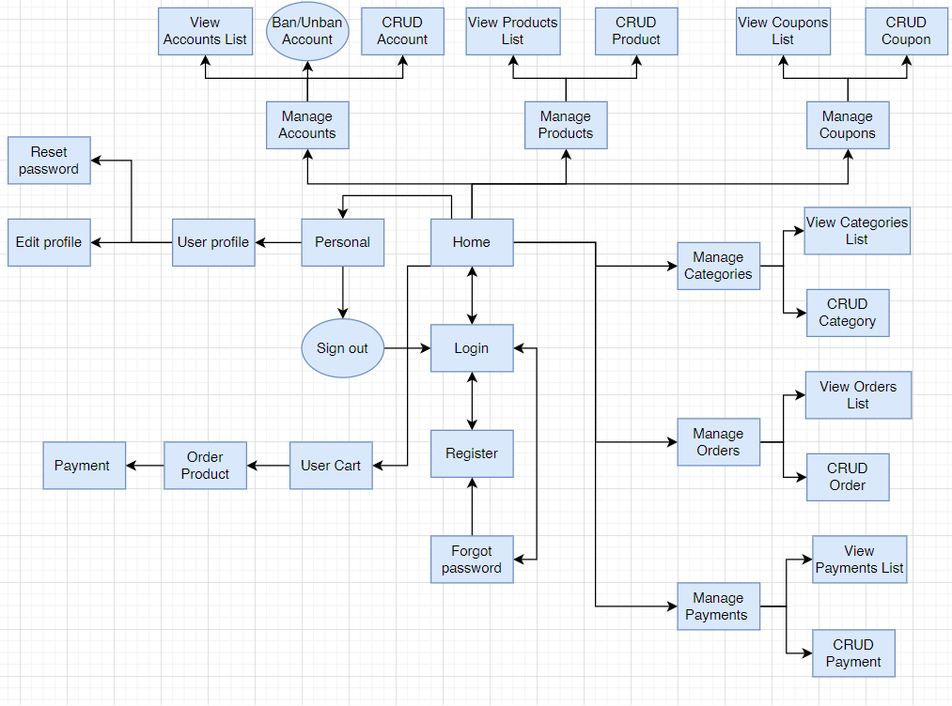

#### **b. Entity Relationship Diagram**

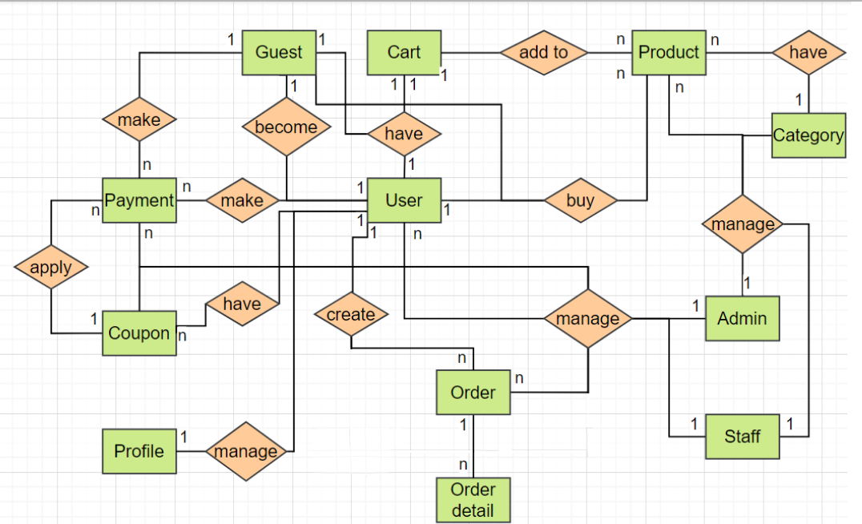

#### **c. Entity List**

|  |  |  |
| --- | --- | --- |
| # | Entity | Description |
| 1 | Guest | The guests register to become users. |
| 2 | User | The user of the Online Shop system. |
| 3 | Staff | The staff of the Online Shop system. |
| 4 | Admin | The admin of the Online Shop system |
| 5 | Product | The stuff that customer want to buy |
| 6 | Category | Describe which products belong to group |
| 7 | Profile | Containing each pieces of information on the account |
| 8 | Order | The request for delivery |
| 9 | Order detail | Containing each pieces of information on the order |
| 10 | Payment | Customer do checkout for order |
| 11 | Cart | Containing product customer buy from website |
| 12 | Coupon | Saving the discount which to apply in product price. |